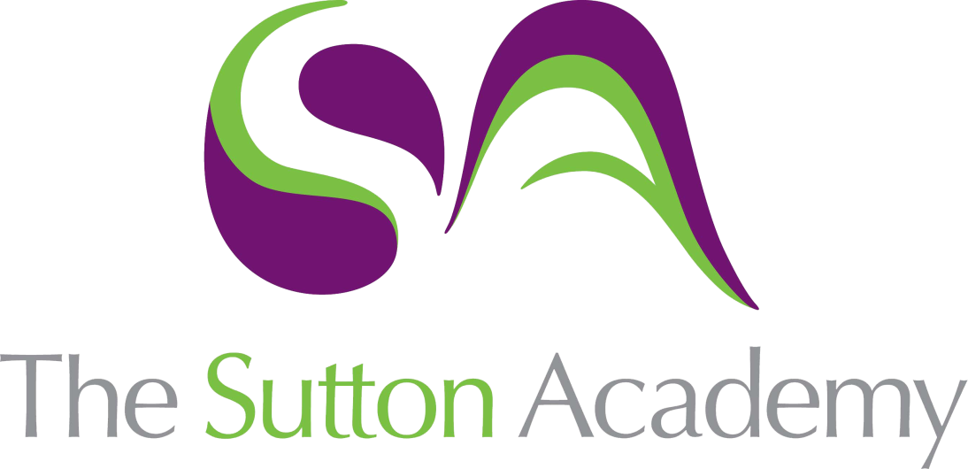

Knowledge Rich Curriculum Plan
SCIENCE- Acids and Alkalis

Lesson/Learning Sequence | Intended Knowledge:  Students will know that… | Prior Knowledge:  In order to know this, students need to already know that… | Working Scientifically | Tiered Vocabulary and Reading Activity | Assessment | Support
Lesson 1 Indicators | Acidic and alkaline solutions may be compared using the pH scale. pH is a measure of the concentration of hydrogen ions in a solution.  A colour change will indicate the presence of an acid or an alkali.  A natural indicator can be made from red cabbage.  Litmus paper can determine whether a solution is an acid or alkali. Red litmus paper will turn blue in the presence of an alkaline, blue litmus paper will turn red in the presence of an acid.  Universal indictor (UI) is a scientific indicator used to determine the pH of a solution. Acids appear orange/red, neutral appears green and alkaline solutions appear blue/purple depending on whether they are strong or weak. | Students already know that different substances have different properties. Students will be able to classify substances into group according to their properties. | Observation  Drawing conclusions from scientific enquiry. | Indicator -  Acid- A substance caused by hydrogen ions, with a pH of below 7  Alkali- A substance caused by hydroxide ions, with a pH of above 7  Enquire- to investigative/look into | Retrieval questions  Simple exam questions  Homework quizzes  Summative assessment 3  Cold call questions:  - How might the concentration of hydrogen ions determine the acidity of a solution  “ The more hydrogen ions in the solution the more acidic that it is, the lower the pH will be”  - How might you determine the pH of a solution?  “Litmus paper or a natural or universal indicator”  - Why might scientist opt for using universal indicator instead of litmus paper?  “ Universal indicator allows an exact pH and to distinguish between strong and weak acids. Litmus paper only tells you if it is an acid or alkali” | Knowledge organiser (provided on Teams and in class)  https://www.bbc.co.uk/bitesize/topics/zn6hvcw/articles/z38bbqt
Lesson 2  pH Scale and Comparing pH | Students will know that pH scale shows the acidity or alkalinity of a substance. The pH scale ranges from 0-14. The colour change that appears in UI determines the strength of an acid or alkali. Students will know that acids have a pH below 7 and appear red and orange. Neutral solutions have a pH of 7. Alkalis have a pH above 7 and appear blue/purple in UI.  Hydrochloric acid, sulfuric acid and nitric acid are examples of strong acids. Acetic acid and citric acid are examples of weak acids. Pure water is an example of a neutral substance. | Students will know that universal indicator and litmus paper is used to identify acids or alkalis. Students will already know that red/orange is an acid, that blue/purple is an alkali, that a green solution is neutral. | Communicate: Students will construct an explanation of the differences between acids/ alkalis and strong/weak acid. | pH scale- A measure of the amount of hydrogen ions  Concentration- the amount of substance in a given volume  Dilute – the act of decreasing the concentration of a solution | Retrieval questions  Simple exam questions  Homework quizzes  Summative assessment 3  Cold call questions:  - How might you increase the pH of a strong acid?  = Add an alkali to the solution or add water to dilute the strong acid.  - How might you distinguish between a strong and weak acid?  = Strong acids have a pH of between 0-3 and weak acids have a pH of between 4-6. | https://www.bbc.co.uk/bitesize/topics/zn6hvcw/articles/z38bbqt  Knowledge organiser (provided on Teams and in class)
Lesson 3  Observing acids and alkali reactions | Students will know that an acid and alkali will neutralise each other and produce a salt and water. This is called a neutralisation reaction.  The name of the salt produced can be worked out from the names of the acid and the alkali.  Chemical equations can be written to describe a neutralisation reaction.  Metals can react with acids to form a new product. Students will know that a salt made from hydrochloric acid will end in chloride. A salt made from nitric acid will end in nitrate. A salt made from sulfuric acid will end in sulfate. | Students should know that a neutral substance has a pH of 7 and appears green in universal indicator. Students should know that pure water is an example of a neutral substance. Students will know why do we get the appearance of bubbles when bicarbonate of soda reacts with vinegar.  Students will be able to explain what happens when an acid appears to get ‘eaten away’ | Collect data and draw conclusions. | Neutralise- the process of reacting acids or alkalis to form salt and water | Retrieval questions  Simple exam questions  Homework quizzes  Summative assessment 3  Cold call questions:  - How might you determine whether a neutralisation reaction has occurred?  = The solution will turn green in universal indicator and have a pH of 7  - How might you determine the name of the salt produced in a neutralisation?  = First take the name of the metal and next will be followed by sulfate, nitrate and chloride depending on the acid used. | https://www.bbc.co.uk/bitesize/topics/zn6hvcw/articles/zvfxxbk  Knowledge organiser (provided on Teams and in class)
Lesson 5  Neutralisation practical and interpreting data | Students will know that a strong acid can be neutralised by a strong alkali. Weak acids are neutralised by a weak alkali. Students will know that a strong acid cannot be neutralised by a weak alkali. | Students will know how to write word equations for the neutralisation of acids and alkalis. Students will know how to use universal indicator to determine the pH. | Enquire: Analyse patterns in data | Anomaly – a data point that is not in line with the rest of the data  Interpret- to explain the meaning of  Variables- a factor that is likely to vary of change  Observation- the act or perceiving  Hypothesis- a proposed explanation | Retrieval questions  Simple exam questions  Homework quizzes  Summative assessment 3  Cold call questions  - What might we need to keep the same in the investigation?  = Volume of acid, volume of alkali, type of acid, concentration of the strong acid | https://www.bbc.co.uk/bitesize/topics/zn6hvcw/articles/z9gnn9q  Knowledge organiser (provided on Teams and in class)
Lesson 6  What is acid rain? | Students will know that chemical reactions between sulphur dioxide and water in the atmosphere may cause a decrease in the pH of rainwater. This is called acid rain. The sulphur compounds released into the atmosphere from burning fossil fuels.  Students will know that acid rain damages the waxy layer on the leaves of trees. This makes it more difficult for trees to absorb the minerals they need for healthy growth and they may die. Acid rain also makes rivers and lakes too acidic for some aquatic life to survive. | Students will know the acids have a pH of 0-6. Students will know that acids appear orange/red in UI. |  | Pollutant- a substance that pollutes something  Fossil fuels- a hydrocarbon formed naturally in the Earth’s crust | Retrieval questions  Simple exam questions  Homework quizzes  Summative assessment 3  Cold call question:  - How might burning fossil fuels contribute the acid rain production?  = burning fossil fuels releases sulfur compounds, which react with water molecules and causes a decrease in pH of rain water. | Knowledge organiser (provided on Teams and in class)  https://www.bbc.co.uk/bitesize/guides/znsk7ty/revision/1

