Electricity mastery booklet

Introduction: So what actually is electricity?

Electricity was not invented by humans. Electricity is a property of the universe. Ever since the first atmosphere formed on earth 5 billion years ago lightning has struck the earth. When the first multicellular life began to form 600 million years ago electrical signals were sent down their nerves to communicate to other parts of their bodies. Electricity is all about the flow of charges. Charges can be either positive or negative and when they move we are dealing with electricity. Electricity flows well down conductors, like metals and salty water, are poorly down insulators, like plastic and wood. Since the 1800’s scientists have been experimenting with electricity. We have managed to find ways of controlling the release, flow and direction of electricity by building circuits. This topic is all about understanding how electrical circuits work.

Electrical circuits

The word circuit essentially means ‘looping path’. In an electrical circuit the electricity follows along a path made by the conducting material (normally a metal wire) in a loop until it returns back to the start. The starting point could be a power pack, which is connected to the mains electrical supply, or a battery. A battery is made from more than one cell. This is the same word as used in biology for animal and plant cells, but it is a very different object. An electrical cell is a small packet of chemicals which can release and electrical current when the ends are connected.
Circuits are complex and each part, or component, can look very different depending on who manufactured it. So we use a set of circuit symbols to make sure everyone knows what a circuit diagram is trying to show.

Here are the circuit symbols you need to know, they will never change.

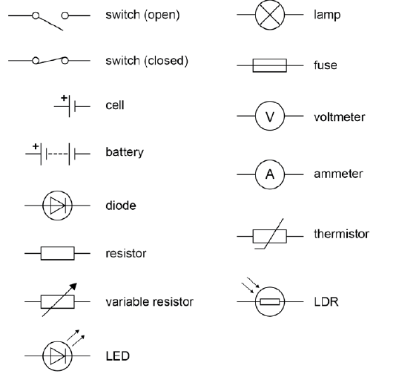

- Give two natural examples of electricity
- Name 2 insulators
- Name 2 conductors
- Give 2 examples of sources of electricity
- Why do we need to use circuit symbols?
- Draw the symbol for a cell and a battery. Explain how they are similar and different to each other
- What store of energy is inside a cell or battery?

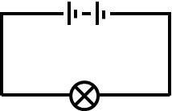
Building circuits practical
Building circuits by following the circuit diagram is an important skill. Look closely at the diagram and build the circuit.
- Make the simple circuit shown on the right
- Check that all your equipment is working

- What happens to the bulb when you use fewer cells in the circuit?
- What happens to the bulb when you use 2 cells in the battery, but add more bulbs in the circuit?
- What happens to the bulb when you use 2 cells and 2 bulbs, but carefully unscrew one of the bulbs from its holder?
- Which of the following will give the brightest bulb? Make sure you give a reason for your answer.
A B
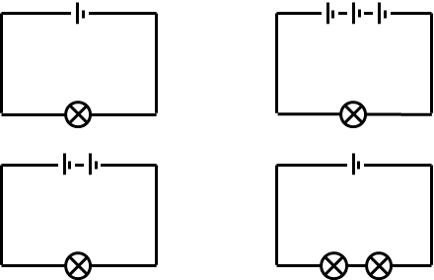
C D

Explaining electrical circuits using models

The charges that move in electrical circuits are incredibly small and impossible to see, but their effects and the rules they follow are visible and predictable. To help us understand these ideas we use a model, or analogy, to explain what is happening. The model is never perfect, but it gives us something to visualise to help us understand. Electricity uses three types of model, the rope model, virtual simulations and the coulomb train model.

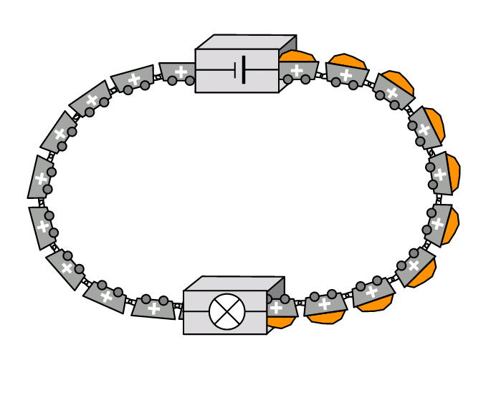
Using the coulomb train model
Look at the picture to the right. In this model the electrical circuit is thought to be made of a continuous chain of train trucks. Each of these is called a coulomb. A coulomb is the unit electrical charge is measured in. The trucks leave the battery full of energy. As they travel clockwise around the circuit they transfer that energy to the bulb, which transfers it on to the surroundings, before returning to gain more. This process can go on again and again until the battery has no more energy left to transfer.

- Complete the table below, The first one has been done for you

What happens in an actual circuit | What happens in a coulomb train model
The electrical charges (electrons) flow | The trucks move around the track
The battery increases the energy of each coulomb
 | The trucks travel on a track
The bulb transfers energy from the coulombs
The electricity appears to work instantly
 | Eventually there is no energy left to fill the trucks

- By looking at the diagram on the right and the coulomb train model answer the following questions in your book in full sentences.
- Explain why when the wire is connected to the battery the bulb lights up
- State what you could do to increase the brightness of the bulb. Explain why this would work
- If the circuit is left on why will the battery eventually go flat.

- Draw the circuit symbol for an open switch
- Draw a circuit symbol for a cell
- What is the difference between a cell and a battery?
- Judith has built a circuit. She has followed the diagram correctly but the bulb is not lit up. Describe what she could do to check the circuit and get the lamp to work. Hint: there is more than one answer.
- Draw a circuit diagram that has 2 cells a switch and 2 bulbs in one loop

Electrical current in a series circuit.

So far we have built circuits and observed a bulbs brightness. We know from the coulomb train model that the ‘trucks’ called coulombs carry the electrical energy to the components of the circuit, like the bulb.
People have been interested in how many coulombs of electrical charge flow through the circuit in a second. A French scientist called Ampere invented a machine called an ammeter which allows us to measure the number of coulombs that pass a point in a second. 1 coulomb per second is called 1 amp. It is given the letter I, because in French its referred to as intensity of current.
In our coulomb train model we can imagine the ammeter to be able to count the number of trucks that pass a certain point in a second. It can’t tell us how much energy they contain just the rate of flow.
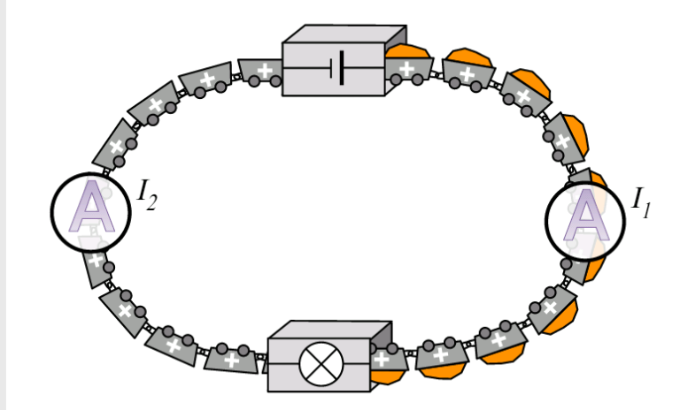
- What is the job of an ammeter?
- What is the circuit symbol for an ammeter?
- Can an ammeter tell you how much energy is stored in each coulomb?
- What component causes the coulombs to flow?
- Which circuit has faster flowing coulombs of charge? Circuit A with a current of 3 amps or Circuit B with 4 amps
- What about if circuit B was twice a long? Explain your answer.

Series circuits
Series means ‘one after another’. For example, in a TV series, episode 2 follows episode 1 and they should be watched in order. In a series circuit all the components are in one loop. If you look at all the circuits, we have built so far they are all series circuits.

Investigating current in a series circuit.
Please only record readings to 1 decimal place.
Series Circuits
Set up this circuit, put your ammeter where it says “A₁”, then “A₂” etc, and WRITE DOWN the readings:-
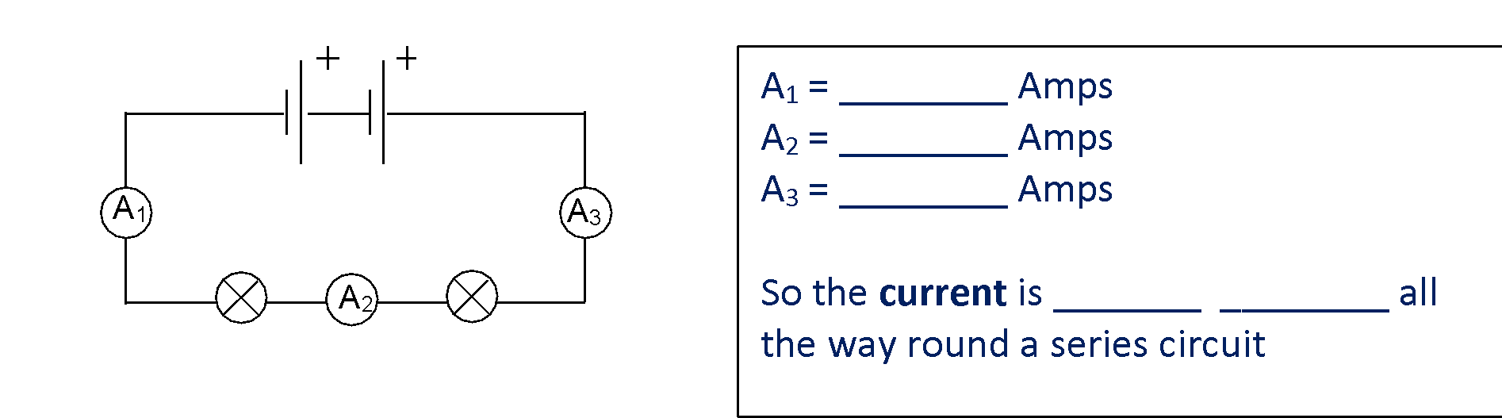

Additional Components
Now add another bulb to your circuit as shown below:

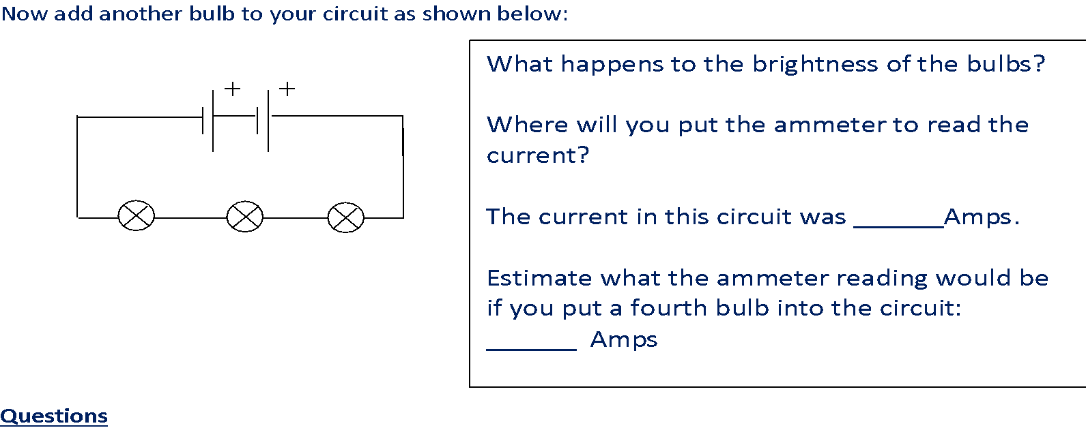

- What can you tell from experiment 1 about current in a series circuit?
- Does the current change if you have more, or fewer bulbs in the circuit?
- Why does this happen?
- What do you notice about the brightness of the bulbs in the circuit?

Explaining the findings using the coulomb train model.
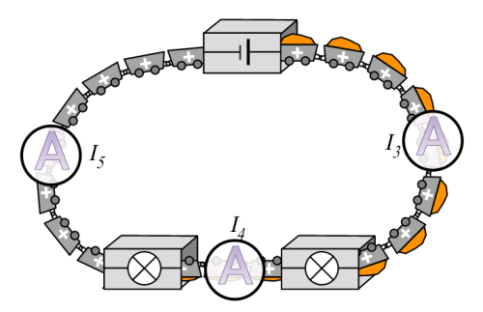
It is very easy to see why the current is always the same in a series circuit. As all the ‘trucks’ are on the same track they all have to pass through the ammeter no matter where it is positioned. So, in the diagram to the right I₃, I₄ and I₅ are all the same.

- How does the current change around a series circuit?
- Austin says; “the current after the second bulb will be less because the bulb has used some up.” Is he correct? Give a reason.
- Is the ammeter connected in series with the circuit?

