Cells, Tissues and Organs
Lesson 1: Microscopes
Cells are the basic building blocks of all animals and plants. They are so small; you need to use a light microscope to see them. A light microscope uses a series of lenses to produce a magnified image of an object:
- the object is placed on a rectangular glass slide
- the slide is placed on a stage with a light source below
- light shines through the object and into the objective lens
- the light passes through the eyepiece lens and from there into your eye
- Use the coarse and fine focus to focus the image in view
Microscopes have three objective lenses. Always start observing an object using the lowest magnification lens first. You may need to adjust the focus and the amount of light as you move to higher magnifications. While a light microscope uses light to illuminate specimens and glass lenses to magnify images, an electron microscope uses a beam of electrons to illuminate specimens and magnetic lenses to magnify images. The resolution (the level of image detailing) is the main difference between these two microscopes
Practical: Investigate a variety of prepared slides using proper microscope etiquette. Practice finding the object in view on the lowest magnification and then increase the magnification and refocus.

- Correctly label the Microscope diagram below:
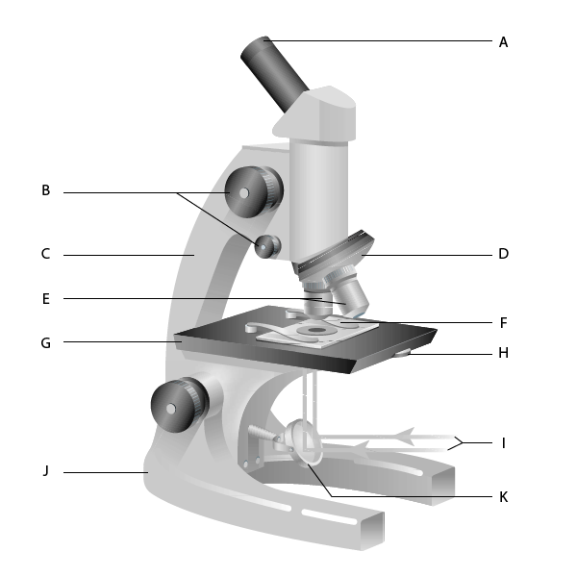

- Write a list of instructions to use a microscope. Complete in workbook.
In your instructions use scientific language. Refer to your labelled microscope diagram to include the correct names of microscope parts.
Calculating Magnification: In science you will be asked to calculate the Total Magnification. This is a combination of the eyepiece magnification (10x) and the objective lens (4x, 10x or 40x).
Total Magnification:

Eyepiece Magnification x Objective Magnification = Total Magnification
Example:
If a pupil is using a microscope with an objective lens of 4x magnification and an eyepiece of 10x magnification. What would the overall magnification be?
10 X 4 = 400x
- Complete the table below:
Eyepiece Magnification | Objective Magnification | Overall Magnification
X10 | X4 | 40
X10 | X10
X10 | X40
X10 | X100

- Which objective lens should you always start with when viewing a slide?
X4 x 10 x100

- Below are some sentences on how to use a microscope. Put them into the correct order.
____ Put the slide onto the stage
____ Turn the focusing knob to bring the cells into focus
____ Look down the eyepiece lens
____ Turn the objective lens to the lowest power
____ Move the slide to find some cells
____Increase the magnification to view the cells in more detail

Unicellular Organisms
A unicellular organism is a living thing that is just one cell. One type of unicellular organism that you may have heard of is bacteria. You may know bacteria as something that cause illness and infection, but bacteria can also have lots of useful functions too. For example, some bacteria lives in your gut and can help you to absorb important nutrients from your food. There are many different types of unicellular organism, including: bacteria, protozoa, and unicellular fungi.
You might be tempted to think that these organisms are very simple, but in fact they can be very complex. They have adaptations that make them very well suited for life in their environment.
In KS2 you would have learned that there are 7 life processes that all living things can do. These life processes have the acronym MRS GREN which means: Movement, Respiration, Sensitivity, Growth, Reproduction, Excretion and Nutrition. Unicellular Organisms are living which means they carry out each process in some way.
Look at the diagrams of Unicellular Organisms below and see if you can work out which parts allow them to carry out each process:
- Bacteria (left picture) are very tiny, unicellular organisms. The structure of a bacterial cell is different to an animal or plant cell. For example, it does not have a nucleus.
- Yeast Cells (right picture) are a unicellular fungi organism. Yeast have a cell wall, like plants do but do not have chloroplasts.
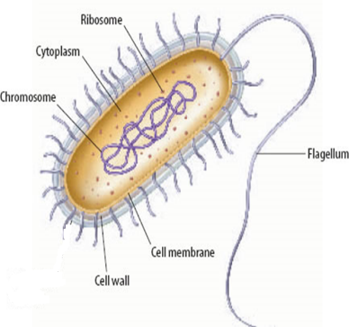
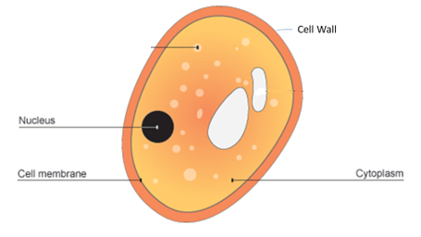

Functions of Cell Parts
Chromosome | Controls the cells features and allows respiration
Flagellum | A tail like structure which allows the bacteria to move
Cell Membrane | Allows nutrients in (nutrition) and waste products out (excretion)
Ribosome | Makes protein to support growth
Cytoplasm | Where many reactions take place

Reproduction of Unicellular Organisms:
Like all living things, unicellular organisms must reproduce. This is done through simple binary fission where they just make copies of themselves and then divide into two.
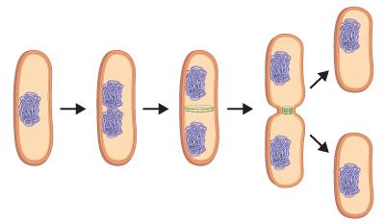
Practice Questions:
Label the cell below:
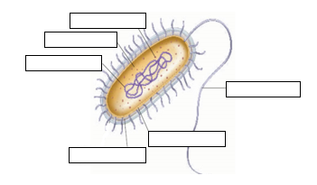

- Name one organelle that a bacteria cell does not have that a plant and animal cell do have.
- What is the function of the flagellum?

- Label the cell below:
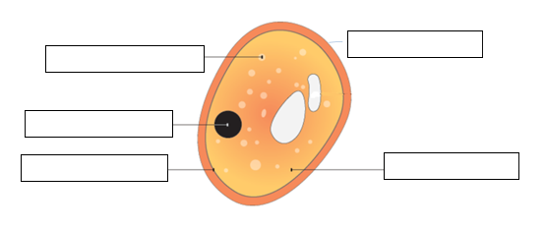
- Name one organelle that is in both a yeast cell and a plant cell.
- What is the function of a ribosome?
- State the three types of unicellular organisms.

- State below whether each function of unicellular organisms is a use or a danger:

____Use__ Bacteria can be added to sewage to break down harmful chemicals
__________ Bacteria live in the gut and help our digestive system
__________ Bacteria and fungi digest dead organisms releasing useful nutrients
__________ Bacteria can infect wounds on the skin after surgery causing infection
__________ Fungi such as yeast are used in brewing and baking
__________ Bacteria can reproduce in the body and release toxins causing disease
__________ Fungi can infect parts of the body causing athletes foot and thrush
__________ Fungi make antibiotics which can be used to treat bacterial infections
Lesson 3 + 4: Diffusion
Diffusion is the movement of substances. You can see diffusion happens when you make a cup of tea or a glass of squash. You can smell diffusion when you spray perfume or burn a piece of toast.
Diffusion always moves substances from areas of high concentration to an area of low concentration. When you put a tea bag into boiling water, the high concentration of tea in the tea bag spreads out to a lower concentration which is the water. Diffusion only happens in liquids and gases because their particles randomly move from place to place.
Diffusion is an important process for living things as it allows substances to move into and out of cells.
Imagine the diagrams below are a tea bag in a cup of boiling water:
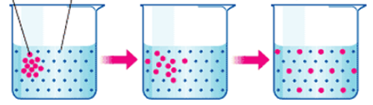

Figure 1: High concentration of tea particles in the top left corner
Figure 3: The particles are now spread out in equal concentration throughout the cup
Figure 2: high concentration of particles has started to spread throughout the water particles in the rest of the cup

Rate of Diffusion
The rate of diffusion is linked to how fast and easily the particles can move. How quickly particles move depends on three factors outlined below:
- Concentration Gradient – The greater the difference in concentration, the quicker the rate of diffusion
- Temperature – The higher the temperature, the more kinetic energy the particles will have, so they will move and mix more quickly
- Surface area of the cell membrane- The greater the surface area, the faster the rate of diffusion
Animal Cells
Animals and plants are made of cells. Tissues are made from cells of a similar type. Organs are made from tissues, and systems are made from several organs working together. Animal cells usually have an irregular shape. This s because animal cells do not have a cell wall. Animal cells contain cell membrane, cytoplasm, nucleus, ribosomes and mitochondria.
- Label the animal cell below using the keywords from the paragraph above:
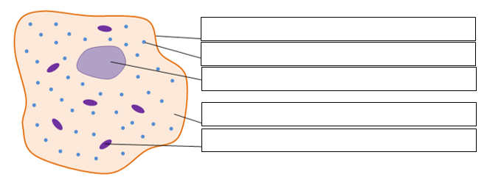
Cell Membrane

- Complete the table below to identify the functions of each animal organelle:
Organelle | Function
Cell Membrane
Cytoplasm
Nucleus
Mitochondria
Ribosomes

Plant Cells
Like all living things, plants are made up of cells. Plant cells have a very regular shape because they, unlike animal cells have a cell wall which provides structure and support. Plant cells are made up of smaller parts called organelles.
- Label the plant cell below:
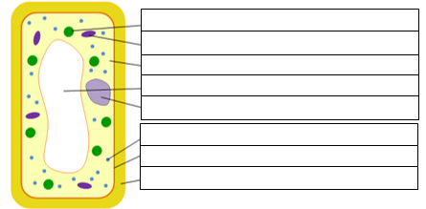
Chloroplast
- Complete the table below to list the function of each of the organelles contained in Plant Cells:
Organelle | Function
Cell Membrane
Cytoplasm
Nucleus
Mitochondria
Ribosomes
Vacuole
Cell Wall
Chloroplast

Plant Tissues and Organs
Animals and plants are made of cells. Tissues are made from cells of a similar type. Organs are made from tissues, and systems are made from several organs working together.
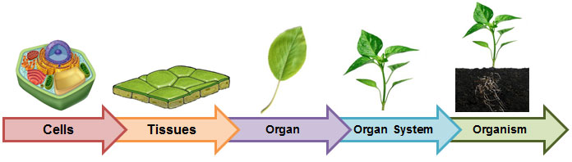

In a plant the organs are the roots, leaves, stem and flower. Each organ in a plant is adapted to carry out a specific function as listed below:
- Root – absorb minerals and water from the soil
- Leaf- absorbs light needed to carry out photosynthesis
- Stem- transports nutrients and water around the plant
- Flower – carries out reproduction of the plant
Comparison of Animal and Plant Cells
64. Label the diagrams to show the names of the parts in each cell.

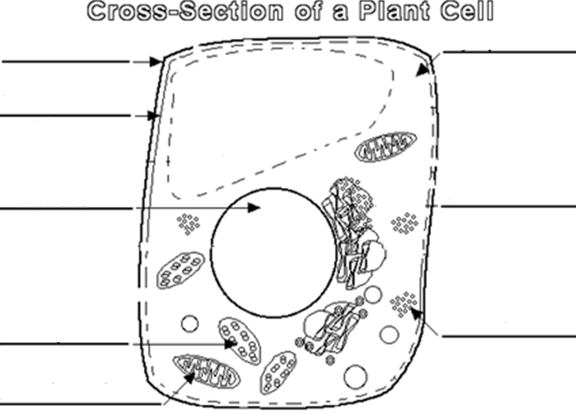

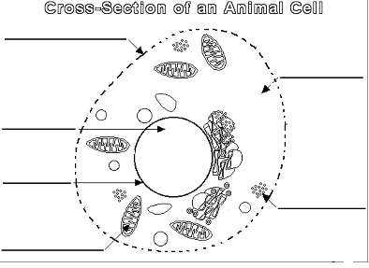

65. Complete the table to give the function of each organelle. The first one has been done for you.
Feature | Function
Cell membrane | Controls what enters and leaves the cells
Nucleus
Cytoplasm
Ribosomes
Mitochondria
Chloroplasts
Cell wall
Vacuole

66. Describe and explain the differences and similarities between plant and animal cells.
67. Where in a plant would you find cells that contain lots of chloroplasts? Explain your answer.
68. Name a type of cell that might contain lots of mitochondria. Explain your answer.

Specialised Cells
Humans are multicellular. That means we are made of lots of cells, not just one cell. The cells in many multicellular animals and plants are specialised, so that they can share out the processes of life. They work together like a team to support the different processes in an organism.
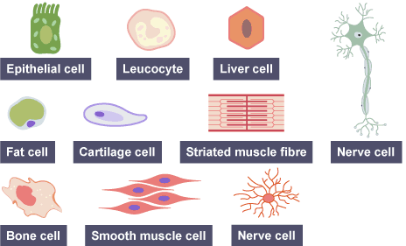
The diagrams show examples of some specialised animal cells. Notice that they look very different from one another.

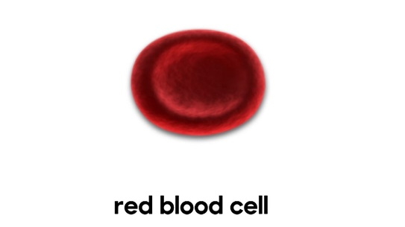
Most cells share features such as having a nucleus, a cell membrane, cytoplasm and mitochondria. There are differences between cells, too. Each type of cell has its own job to do. These cells have special features that allow them to perform their functions effectively. Here are some examples of specialised cells and the features they have to help them with their role:
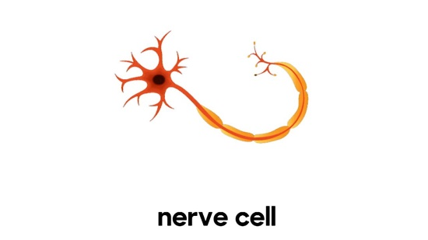
Red blood cells: carry oxygen around the body. They are well suited to this function because they contain haemoglobin, which carries oxygen molecules. They don't have a nucleus, allowing more space to carry oxygen. They are a flat disc shape (bi-concave) which gives them a large surface area, and the best chance of absorbing as much oxygen as they can.
Nerve cells: transmit electrical signals. They are well suited to their function because they are thin and can be more than 1 metre long. This means they can carry messages up and down the body over large distances. Nerve cells have branched connections at each end. These join to other nerve cells, allowing them to pass messages around the body. They have a fatty (myelin) sheath that surrounds them. The fatty sheath increases the speed at which the message can travel.

Specialised Cells in Plants
Each organ of a plant is made up of specialised cells and tissues. The roots are composed of root hair cells which absorb nutrients and water from the soil. The stem is made up of the xylem and phloem which help to transport water and nutrients throughout the plant. The leaf is composed of palisade cells, these have lots of chloroplasts to maximize light absorption for photosynthesis.
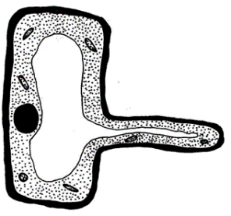
Root Hair Cell: absorbs minerals and water from the soil. Adapted to have a long hair like structure that increases the surface area of the cell membrane to allow for the uptake of minerals and water to take place more efficiently. Root hair cells have a thin cell wall so it easier for particles to diffuse. These cells also have no chloroplasts, if you recall chloroplasts function is to absorb sunlight for photosynthesis, as roots are located underground, they do not perform photosynthesis and therefore have no use for chloroplasts.
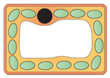
Palisade Cell: function to enable photosynthesis to be carried out. They are located at the top of the leaf to maximise the amount of light absorbed. They are also adapted to have a lot of chloroplasts which absorb light energy used in photosynthesis.
Comprehension Questions:
- List the structures that are missing from the root hair cell compared to a regular plant cell.
- What are the adaptations of a root hair cell?
- Why does a root hair cell not have chloroplasts?
- What adaptations does a palisade cell have?
- What is the function of the chloroplast?
- How do minerals from the soil move into the cell?
Organ Systems
85. Label the diagrams. Use these terms: Organ system tissue cell organ
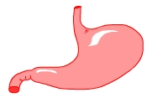
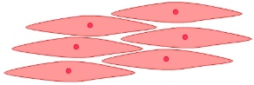

_________________ _________________ _________________ ________________

86. a) Label the organs shown.
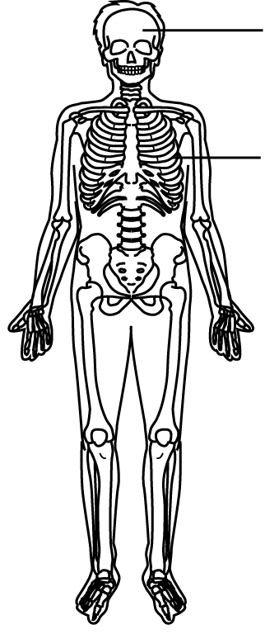
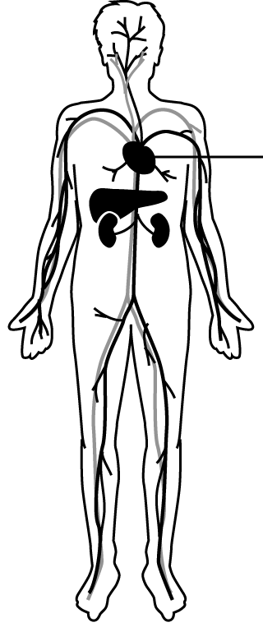
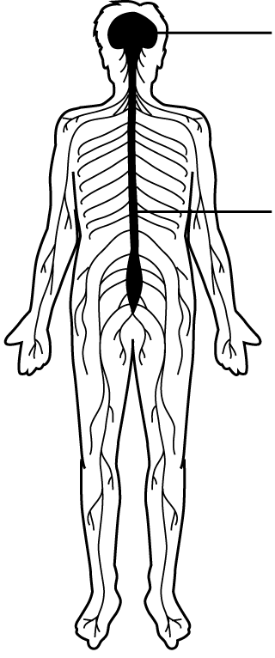

b) Name the organ systems
A. ………………………… system B. ……………………….. system C. ………………… system
c) Describe the function of each of the organ systems shown above.
87. Name one other organ system in the body and describe its function
88. The lungs are part of the respiratory system. Their job is gas exchange – oxygen into the body and carbon dioxide and water out of the body. Explain how the tissues in the lungs are adapted to make sure this happens efficiently. Complete in your workbook.

Digestive System
The digestive system is the organ system that breaks food down into small molecules that are absorbed into the bloodstream. Digestion is helped by enzymes, which are biological catalysts. The food we eat has to be broken down into smaller substances that our bodies can use. This is called digestion. Without digestion, we could not absorb food into our bodies and use it.
Digestion happens in the digestive system, which begins at the mouth and ends at the anus.
- Label the diagram below using the following keywords: Liver, Stomach, Anus, Mouth, Oesophagus, Small Intestine, Large Intestine, Pancreas.
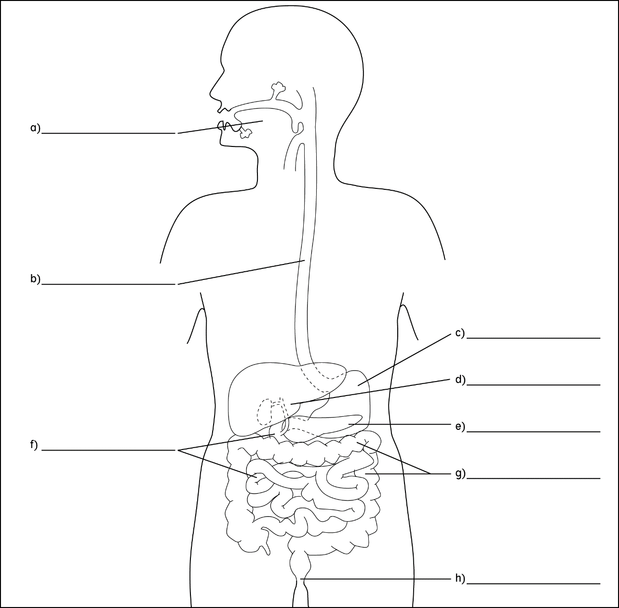
After we swallow, our food passes through these organs in turn: oesophagus or gullet, stomach, small intestine, large intestine. Different things happen to food as it passes through the digestive system:
- food is digested in the mouth, stomach and small intestine
- digested food is absorbed into the bloodstream in the small intestine
- excess water is absorbed back into the body in the large intestine
- any undigested food passes out of the anus as faeces when we go to the toilet
The liver and the pancreas play an important part in digestion. The liver produces bile, which helps the digestion of lipids (fats and oil). The pancreas produces biological catalysts called digestive enzymes which speed up the digestive reactions
- Complete the table below with the functions for each organ of the digestive system:
Organ | Function
Mouth
Oesophagus
Stomach
Small Intestine
Large Intestine
Liver
Pancreas
Anus

